ENCLOSURE 1_STATEMENT OF WORK

BACKGROUND
The five-year USAID-funded Feed the Future Bangladesh Agricultural Infrastructure Development Activity (Agricultural Infrastructure Activity or Activity) aims to address the infrastructure needs of farmers through design and construction of agriculture infrastructure, mainly rural rods, culverts, rural market vertical infrastructure, market internal roads, and drainage.
By investing in rural infrastructure, USAID will increase incomes, create jobs, reduce post-harvest losses, improve agricultural productivity and production, and strengthen food security. The Activity operates primarily in Faridpur District in Bangladesh.

SCOPE
The Activity is seeking a survey firm to provide ad hoc survey services through May 2026. The selected offeror will be issued purchase orders under the overarching agreement to be issued as a result of this solicitation process. The pricing rates proposed as part of this solicitation for each calendar year will be included in the resulting subcontract and all purchase orders issued thereunder will use said pricing.
The survey firm will be responsible for the site surveys, inclusive of detailed topographical, engineering, and bathymetric survey works for rural roads, rural market centers, and drainage within a specific market catchment area as defined in detail in the purchase order statement of work. The purpose of the site survey is to provide a detailed survey of the topographical features of the market infrastructure such as internal and surrounding roads, sheds, drainage facilities, etc. The topographical survey report will supplement the scoping assessment report and be used to prepare detailed designs by Amentum.
The survey subcontractor shall possess adequate logistics support like transport facilities, survey equipment (Total Station, Theodolite, Level Machine, Telescopic Alidade, Computer, Laser Printers, software, Plotter, Digitize, hand-held GPS etc.), and office accommodation with telephone, internet facilities so that Amentum can supervise the day-to-day progress of the services. The survey subcontractor shall ensure the availability of this logistical support throughout the execution of the services. The subcontractor shall include cost of logistics and travel to carry out the assignment effectively in the unit rates.

ELIGIBILITY
The survey firm shall be registered as a survey company in Bangladesh. The company must have at least 5 years of experience and relevant past performance in line with the scope of work described herein.

PURCHASE ORDERS
The following outlines the sample scope and deliverables of the purchase orders to be issued under the subcontract agreement resulting from this solicitation. Purchase orders will provide further details of the requirements and deliverables.

Task 1: Implementation Planning
Schedule. The subcontractor shall provide a quick schedule defining key dates especially when the survey team will conduct survey assessments and internal quality control prior to data submission.

Task Order Quality Assurance/Quality Control (QA/QC) Checklist. The survey firm must submit a purchase order QA/QC checklist and define internal senior reviewers based upon the task order technical requirements.

Task 2: Maps and Data collection
Collect cadastral survey data of the project area proposed for the improvement works to include property boundaries, parcel numbers, and owner names.

Task 3: Survey and Site Investigations
The survey firm will complete a topographical survey necessary for Amentum to produce detailed designs. The requirements will be further defined in individual task orders. The following describe general requirements for all surveys:
- Topographic survey shall be completed using total station.
- RL (Reduced Level) should be carried from nearest PWD/SOB Benchmark pillar with detail description of GPS of the benchmark pillar. Temporary benchmarks shall be established on the permanent objects along the road/markets/ irrigation infrastructure that can be easily visible and marked with value and GPS co-ordinates in the drawings. Back check shall be done during benchmark fly and shall consider in meter SOB. The surveyors undertaking this work in the field shall attend the pre survey training session led by Amentum.
- The plans shall show the horizontal control. Show at least two GPS co-ordinates (Latitude-Longitude and Easting and Northing) at both ends for each road, drainage or irrigation canal, and embankment in the sub-project.
- Water features within the project area such lakes, rivers, streams, ditches, ponds will include information on the bed level, high flood level in last 30-years and low water level based upon local information, bed levels of the features with respect to datum.
- The survey firm shall conduct a utility survey for the entire length of the targeted roads, for market centers, or along an irrigation canal to assess the locations of utility service lines (both buried or above ground) and propose utility relocation if necessary.
- The survey firm shall assess the requirements and availability for waste/spoil disposal areas.
- The survey firm will verify the alignment, orientation, and location of topographical survey works that they will do by superimposing on Google maps for accuracy. If it is correct, then they will submit all the survey works.
For rural markets, the survey provider will be required to conduct a topographic survey of the market areas with a minimum radius of 300m beyond the market facility which includes:
- Topographical survey shall include all existing physical features, shops, buildings, toilets, tube-well, ponds, internal roads with earthen shoulder, drainage networks with drain sizes and sill levels, flow direction, outfall etc. along with levels in grid forms so that the slope of the roads or ground can be identified.
- A photo log and photo layout map showing photo direction with number shall be provided in separate drawings.
- The area of government hat periphery/khas land, private commercial area, and proposed location of infrastructure including land ownership as verified with the local Union land office shall be shown in the survey report.
- If the market is situated near the river and there is a possibility of bank erosion, then cross-sections of river bank up to inside the riverbed with closer interval shall be taken so that erosion pattern can be identified.
For rural road surveys, the survey works are split into two stages. The topographical survey is the first stage and after completion of first stage and satisfactory submission and acceptance of survey report by Amentum, the Amentum Design Manager will notify the survey firm to conduct the second stage of the survey, namely the engineering survey. The multiple trips and/or other costs associated with this two-stage process must be included in the unit rates provided in the pricing sheet as these rates are not subject to change for any purchase orders. For road surveys, the following is required:
- The entire road alignment should be surveyed in plan form through topographical survey by total station showing detailed end road connectivity, all physical features with necessary information along and besides the road including connecting roads, electric or telephone poles, trees, houses, ponds, canals, road crossing structures, drainage sluice, paddy fields, irrigation channels or pipes, adjacent land terrain, drainage path etc., and cross-sections of the road shall be taken and plotted in appropriate scale.
- A photo log and photo layout map showing photo direction with photo number shall be provided in separate drawings. Photos must be taken in four directions.
- Show cut sections of existing structure, approach road beside the road, and both ends of the roads.
- At culvert/bridge locations, the river, stream, or canal cross sections shall be taken upstream and downstream. For bridges, additional sections of the stream, at 100 meters upstream and downstream of the structure, should also be taken.
- Conduct roadway field reviews to analyze and document existing field conditions within a minimum of 20m offset from the centerline, or wider if necessary, and note any differences between existing field conditions and the data provided to Amentum. Document unique site features using photographs or videos as appropriate.
- At curves, intersections, culvert and bridge locations, cross sections shall be taken at closer intervals. In areas where the road surface will be level with or below existing terrain or homestead areas, protection for roadside house and storm drainage features will be needed, additional spot levels will be provided at 5.0 m interval up to 25m apart from road toe on both sides of the road.
- Road cross-section shall be taken at 25-meter interval along the road with spot levels be taken in such way that the actual road section would be available and to be as appropriate to determine earth volume needed to upgrade the road embankment. Additional cross-sections shall also be taken if canals, ponds, ditches, homestead areas exist adjacent to the existing road, or a certain reach of the existing road is required to be realigned.
- Sufficient road cross-sections shall be taken if road adjacent ponds, ditches or canals exist so that the design team can take appropriate embankment slope protection measures.
- The survey company will collect the mouza maps along the existing road alignment, digitize the mouza map (cadastral map) on which the topographic survey map will be superimposed, using appropriate GIS tools and methods, with accuracy so that the design team can identify and prepare a land schedule.
- Specific site survey will also be required if new drainage structures (U-drain, culvert, drain etc.) are required as per instruction of Amentum Design Manager.
The survey company will provide the following deliverables:
- Topographical survey report superimposed over mouza map (cadastral map)
- Engineering survey report
- Photo log
- Tree Inventory list including the GPS locations
For irrigation designs, the survey firm shall:
- Establish the following through topographic longitudinal and cross-sections of drainage channels/khals: embankments, irrigation canals, structure sites, and land elevation spot levels over the irrigation/drainage area. The topographical survey must include all physical features within the existing drainage catchment area within 1000ha.
- The existing ground levels will be taken at an interval of 25m or closer where land levels change rapidly.
- The long-section and cross-section of embankment will be done at an interval of 50m or closer where land levels change rapidly or as per instruction of Amentum.
- The long-section and cross-section of canal will be done at an interval of 50m or closer where land levels change rapidly, or canal curvature exists, or as per instruction of Amentum.

Task 4: Drone based survey capturing 4-5km radius of the market centers (if specified in purchase order SOW)
PAE would like to conduct drone surveys around the market centers to provide data related to agriculture land, roads, irrigation canal etc. The drone operator must have license from appropriate government authority of Bangladesh.

Task 5: Construction Implementation Support
The survey firm if requested by Amentum shall support the construction subcontractor through providing project layout, road curve setting, identification of government owned land at roads, markets, and irrigation infrastructures.

SAMPLE PURCHASE ORDER
The following pages are an example of a purchase level statement of work which will be issued under the subcontract agreement resulting from this RFP to assist the offerors in assessing pricing rates. The following is only an illustrative, not an exhaustive sample and offerors should be mindful of all requirements and terms of conditions in the RFP, draft subcontract, enclosures, and this statement of work when proposing pricing.

PURCHASE ORDER STATEMENT OF WORK (SOW) FOR THE SITE SURVEY SERVICES
OF
Sownirbhor road under Madhukhali upazila of Faridpur district and Baliakandi upazila of Rajbari district.

The following statement of work supplements but does not replace the subcontract level statement of work under which this purchase order will be issued.

ROAD NAME
Sownirbhor road under Madhukhali upazila of Faridpur district and Baliakandi upazila of Rajbari district.
Road Classification:
- Baliakandi upazila: Magchami-Kamarkhali Roads and Highways Department Road, LGED code number 382074057
- Madhukhali upazila: unclassified road

LOCATION
The Sownirbhor road is 3.45 km long, starts at Khurdo Megchami Eid Gaon (Lat:23.6069918, Long:89.5603994) of Baliakandi union in the Baliakandi upazila of the Rajbari district, and ends at the Norkuna village jora bridge (lat:23.5763709, long:89.5580964) in the Magchami union of the Madhukhali upazila in Faridpur district. The length of the road within the Baliakandi upazila is approximately 1.6 km (chainage 00-1,600m) while the length within the Madhukhali upazila is 1.85 km (chainage 1,600-3,450m).

SCOPE OF SURVEY WORKS
The site survey work shall be carried out for 3.45km length of the road including the roadside canal on east side of the road based on but not limited to the SOW of the subcontract level statement of work executed between the survey firm and Amentum-PAE. The survey firm shall complete the survey report under the guidance of the Design Manager of Amentum-PAE team. A pre-survey meeting organized by Amentum will take place in Amentum-PAE office, Dhaka.

The survey report shall include the existing roadway plans and sections superimposed on the respective mouza maps (cadastral map) identifying land ownership (Government/Private) including estimating the land quantity, hydrological data such as highest flood level (HFL) in last 30 years, normal water level (NWL), low water level (LWL) etc. during the period of monsoon season from local information.

The survey works are split in two stages. The Topographical survey is the first stage and after completion of first stage works and satisfactory submission and acceptance of survey report, the design manager of Amentum-PAE will notify the survey firm to conduct the Engineering Survey, the second stage survey works.

The survey firm will perform first a topographical survey of the road showing road pavement edges, road crest edges, road toe to toe including all physical features, roadside canal on east side, approach/link roads, shops, houses, gardens, ponds, trees, light post, ground, culverts, gaps and breaches, road levels or certain reach of the road needs to realign etc.

After acceptance of the topographical survey report, the Amentum-PAE Design manager will notify the survey firm to start the second stage engineering survey works. i.e., long-section, x-sections, and other spot levels (ground level, plinth level of houses, shops, pond/ditch water level etc.) with respect to permanent benchmark (SOB or PWD) reference. The water levels at different conditions including HFL etc. will also be recorded. They will capture photographs in four directions for each road cross-section, will take information and cut-sections of the existing culvert/U-drain with photographs (at least four photos for each object) and find out any requirement of drainage structure through discussion with the local stakeholders and the Activity’s project planning team of DAM lead by the Senior Community Participation Specialist. If found necessary, the survey firm shall perform a grid survey of the drainage structure site. Closer sections and sufficient photographs shall be taken near ponds that have potential for slope protection work.

The survey firm shall collect appropriate data and photographs of all the facilities preliminarily proposed for development for this road projects per below.
- Improvement 3.45 km Sownirbhor road with appropriate pavement type.
- Roadside slope stabilization along the canal (east side) for full road length of 3.45 km.
- Repair/upgrade/reconstruct the existing small culverts and bridges of the road.
- Repair/upgrade/reconstruct the existing two sluice gates currently being used as water control structures as well as RCS.
- Straightening the curved part, the road at the 1st sluice gate at 2, 806 m (see annex I) and constructing a bridge/culvert over the canal which links to the main canal.
- Repair/upgrade/reconstruct the culverts/bridge on existing linked roads emerged within first kilometer of HBB road which connect homesteads.
- Proposed five mechanization landing points on the right side (west side) of Sownirbhor road (see annex I) to construct the best fit ones for safe movement of agricultural machinery (tractors, combined harvester, power tiller, etc.) to the crop fields of Chaibanga Beel.
- Proposed two mechanization landing points on left side (east side) of Sownirbhor road to construct the best fit ones including construction of bridges over east side canal for safe movement of agricultural machinery (tractors, combined harvester, power tiller, etc.) to the crop fields of Beel Singnath.
- Proposed two farmer’s sheds on right side (west side) of Sownirbhor road to construct the best fit ones for resting and washing hands.

In addition, the survey firm should collect data and photographs of other objects located close to the road such as Jora bridge, bridge over Fuleshari river that connects this road with Beel Aralia to Kamarkhali road, all link roads, and the culverts on the link roads etc. The survey firm should take photographs of all stakeholder consultations and attach with the report. A picture of alignment of the proposed Sownirbhor road in sketch Map is presented in Annex-I.

LIST OF DELIVERABLES
The survey company will provide the following deliverables as per SOW:
- Topographical survey report superimposed over mouza map
- Engineering survey report
- Photo log
- Tree Inventory list including the GPS locations
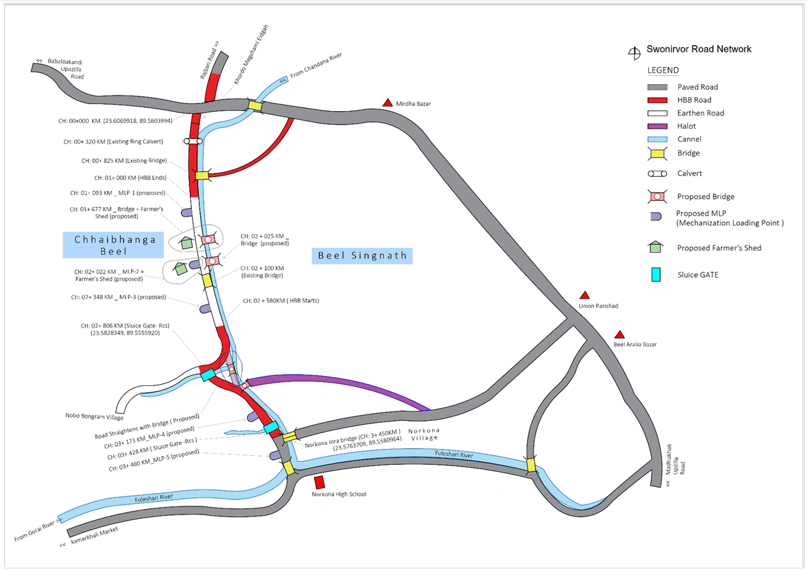
ANNEX I. EXISTING AND PROPOSED INFRASTRUCTURE SKETCH MAP

